Character Development over time

# Tool Selection

Initially, I considered utilising something like Paint.net or GIMP, as they are well-known for both pixelated art and ease of use. After a few attempts, I decided to try and use Adobe Photoshop, which worked very well in terms of constructing pixelated art. Graphical tablets were unavailable hardware, so a mouse was used to construct the sprites.

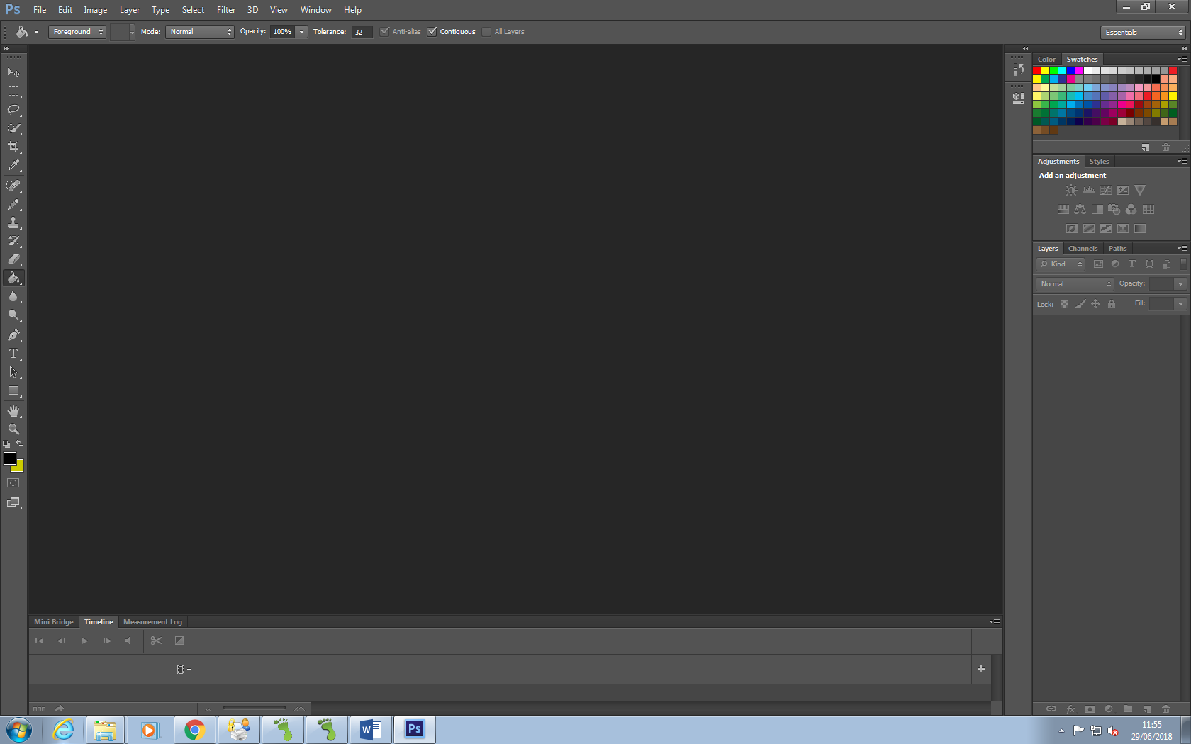

# Initial Design

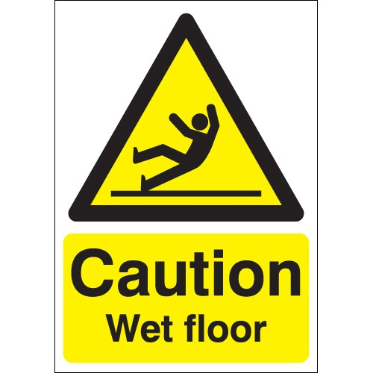The initial design was a simple sprite within a 50 pixel by 50 pixel canvas. The character itself was a small stick-figure, similar to informational signs.

I chose this design out of both simplicity of initial creation, and for ease of further development on the sprites. A simple base sprite would allow me to branch further with animation and minor details to change the character from a simple figure to an advanced figure.

F:\Game1\images\unused\man01.png

The figure itself was designed in Adobe Photoshop, for ease of drawing.

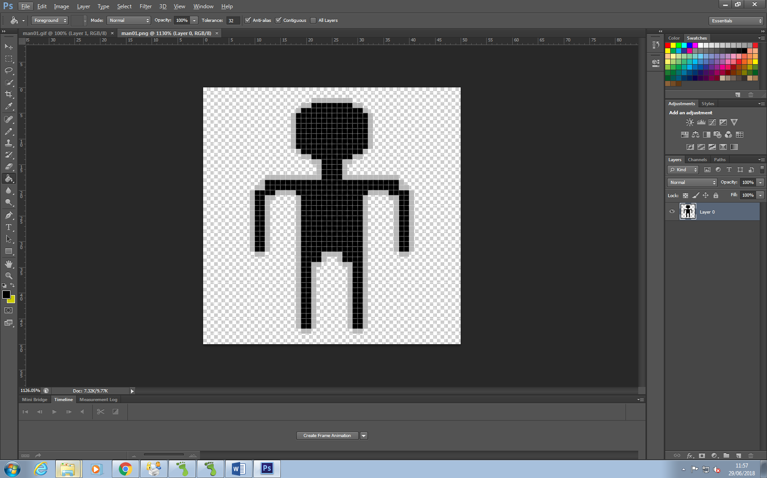

# Continued Development

As game development went on, the character had to be adjusted to fit the rest of the art style. The background on most levels was black, which meant the character had to be adjusted for visibility. F:\Game1\images\unused\man00.jpg

The adjustment was performed in Adobe Photoshop.

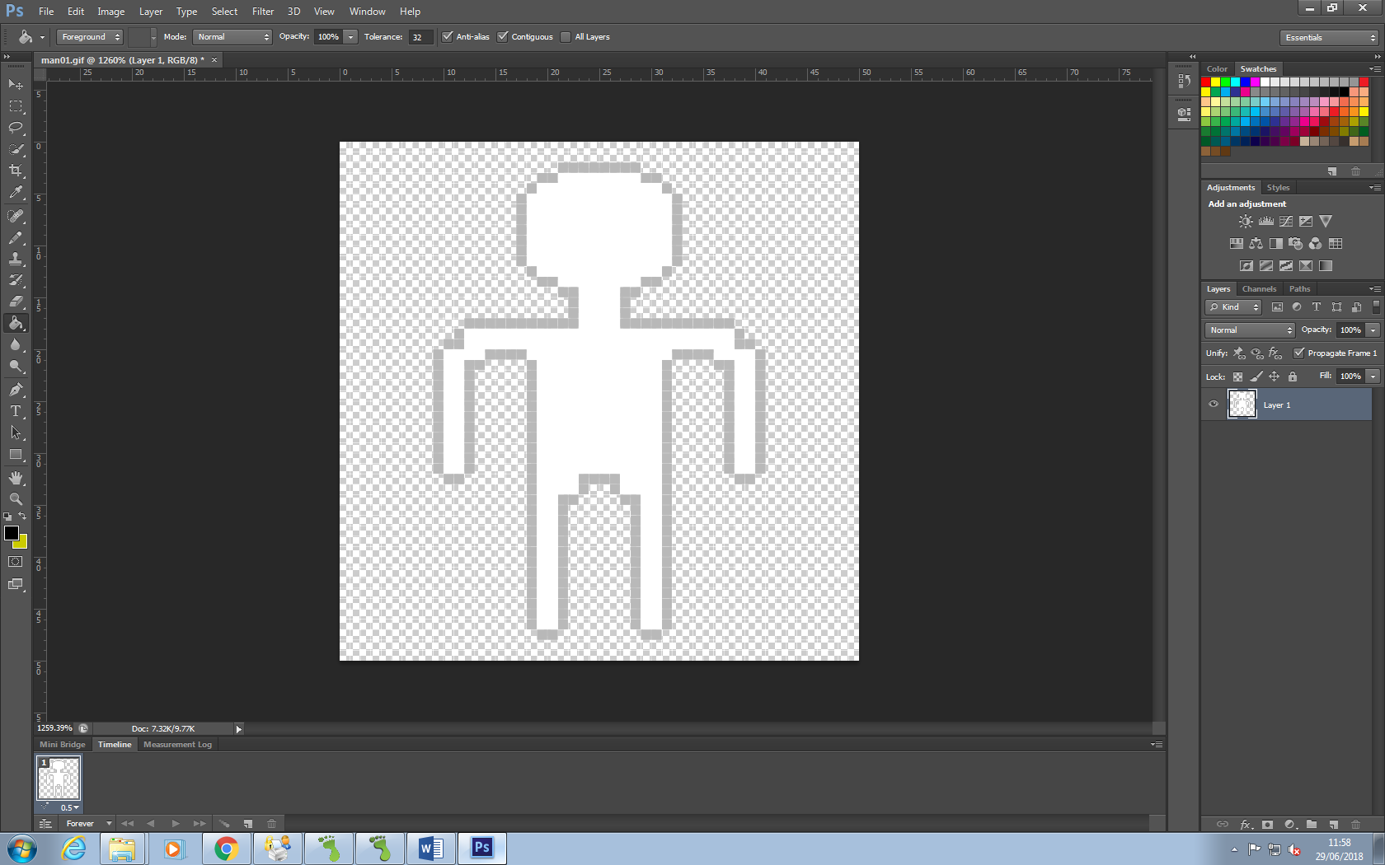

# Animation

The character gained a second frame of animation to mitigate the lack of animations in the game at the time.

